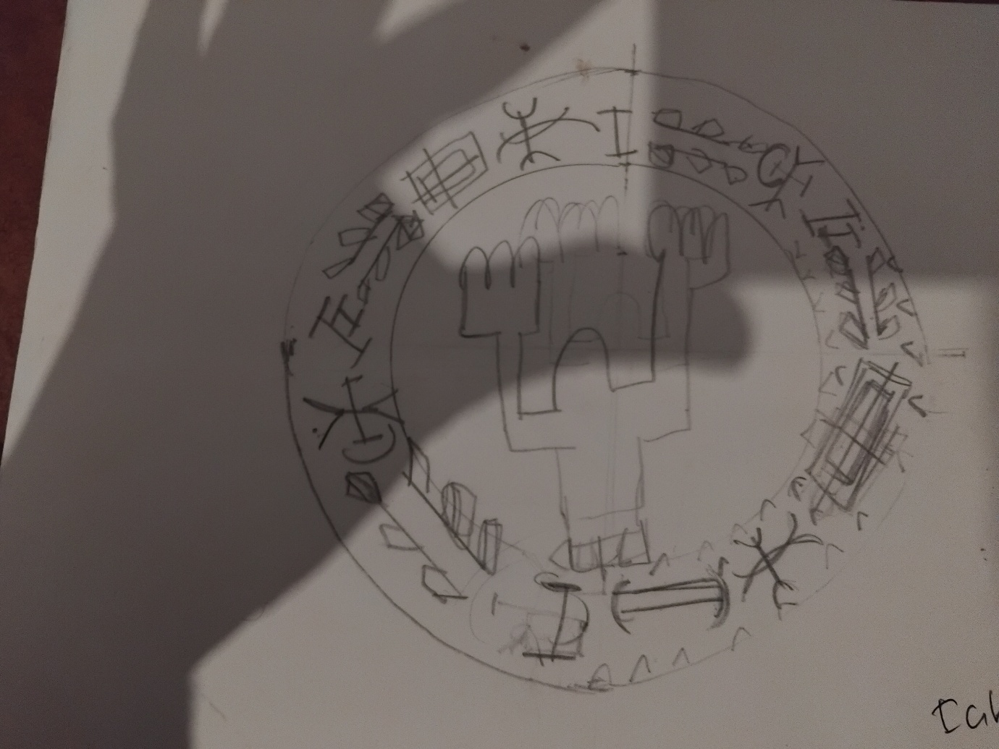

As A child, I wandered along the tracks of a system that failed me journey in a reflection of myself, Uche / knowledge and eze /king obi heart/soul nexus connection in reflection of what is yet to be.

In reflection o what I stood for, I became in to return from failed intrastate I emerge an adult.

As a adult , I journey back to the infrastructure that failed too many generation like me . I wander back in reflection as an adult, having contracted knowledge and hardship, and kingship shared. I return to Obi.

When Systems Fail, I Built my OWN – and you MUST too.



OBINexus Nnamdi Michael Okpala  
AuraSeal Insignia Manifestatation Brand  
birth /manifest from blood , sweat and tears  
fighting the system of the forced a cycle of opperasion and depression – for what is yet to become, I became. (Insignia )